Project and Messaging Outline for Firewood Awareness Month, October 2018
This document is designed to help outreach professionals, stakeholders, and other members of the larger phytosanitary community understand the intent of Firewood Awareness Month. It includes the goal, partner information, weekly themes, sample social media messages, and graphics to allow for convenient participation.
Document Quick Reference:
1 … Introduction, Goal, Partners, and Schedule
2 … Regionally Specific notes
3 … October 1 - 6 Theme: General Information: general information regarding the issue of firewood as a pathway for forest pest spread.
4 … October 7 - 13 Theme: Fall Recreation: messages targeted to fall recreationalists- especially hunters, anglers, and RV owners.
5 … October 14 - 20 Theme: Firewood as a Forest Product: Firewood's important role as a forest product during National Forest Products Week
6 … October 21 - 27 Theme: Home Heating and Cordwood: Messages targeted to people that buy or gather firewood to heat their homes or cabins.
7 … October 28 - 31 Theme: General Information and Halloween sample text
8 … Sample image bank

Goals: Firewood Awareness Month’s primary goal is to raise public awareness about firewood movement as a forest pest and disease pathway. The secondary goal is to nudge people in the direction of their most easily accepted best practices for firewood buying and/or gathering, which will depend on their firewood use situation. We established theme weeks to organize best practices based on situations and audiences, though we invite you to participate however it makes most sense to you.
Leadership: USDA’s Hungry Pests campaign and The Nature Conservancy’s Don’t Move Firewood campaign jointly manage the awareness month.
Contacts: Reach The Nature Conservancy’s Forest Health Program Director Leigh Greenwood at lgreenwood@tnc.org and Hungry Pests Campaign Manager Abbey Powell at abbey.powell@aphis.usda.gov.
Audience: Outreach professionals, stakeholders, and other members of the larger phytosanitary community, such as State Departments of Agriculture, Agriculture Extension Offices, Nonprofit organizations, and any other entity that wants to promote this educational effort through their outreach channels.
Schedule: Each week in October has a theme. These themes allow partners to strategize when to “chime in” according to their preferences, audiences, and professional time constraints. There is no minimum requirement to participate, and it is not a problem if a given partner wishes to ignore the theme schedule due to their state or regions’ needs.

NEW FOR 2018
- Six new radio advertisements are available at https://www.dontmovefirewood.org/new-dont-move-firewood-radio-advertisements-available/
- Four new Infographics and accompanying Social Media ready images will be rolling out in late September and early October, aligned with the Firewood Month themes. Find these as they are published, at https://www.dontmovefirewood.org/firewood-month-toolkit/ under the “Infographic” and “Social Media Guidance” listings, respectively.

Notes on regional specificity of Firewood Awareness Month messages:
- In areas where certified heat-treated firewood is widely available (in general, states within the federal Emerald Ash Borer federal quarantine boundaries), it may be advisable to focus on heat treated firewood, and not recommend local firewood as strongly. “Local” has many possible interpretations, while heat treated firewood is a regulated product.

- The likelihood of gathering firewood on site being legally permissible and environmentally sustainable varies greatly by region and land ownership patterns. Please make the decision to promote gathering or harvesting firewood based on your best judgment for the area you are targeting.

- The answer to the question of “how can I figure out where to buy firewood?” varies greatly by region. Some state Departments of Forestry or Agriculture maintain an online directory of approved dealers. Ten states list their vendors on Firewood Scout, a cooperative firewood vendor locating website (http://firewoodscout.org/). Some states and areas have no online information to speak of. Do a brief search to see what options are available, and then recommend whatever best options you find.

- You will see many messages in the sample wording pages that follow the rough pattern of “the trees cut for firewood often died due to insects or disease...” This wording has been extremely popular with the general public on the Don’t Move Firewood social media accounts, as people often envision firewood as being cut from dead or declining trees. However, this may not be applicable to commercial or large-scale operations, especially in the Eastern states.

You may find it helpful to consult the maps and state specific resources at these URLs:
- https://www.dontmovefirewood.org/map/
- https://www.aphis.usda.gov/aphis/resources/pests-diseases/hungry-pests/Pest-Tracker

WEEK ONE: October 1 – 6: General information, disseminating ideas, promoting press releases describing the issues of firewood and the spread of forest pests.

Suggested outreach landing page: https://www.dontmovefirewood.org/firewood-month/

General messages and sample wording
Our messages will strive to include a brief summary of the issue of forest pests and the firewood pathway, followed by positive messages of what each person can do to make a difference. Sample wording and concepts follow.

Moving firewood long distances can spread forest pests. Your firewood choices matter. You can protect the places you love by preventing the spread of forest pests on firewood. Don’t move firewood – instead, buy firewood where you’ll burn it, buy certified heat treated firewood, or gather on site when permitted. You have the power to slow the spread of forest pests.

The Don’t Move Firewood campaign promotes the following three choices, which each participant in Firewood Month should regionally tailor and select according to factors in their local firewood situation:
  - Buy certified heat treated firewood.
  - Buy it where you burn it / Buy firewood near where you’ll burn it.
  - Gather firewood on site where permitted.

Sample wording of social media posts during the first week:
(Please tag Twitter posts #FirewoodMonth to allow for campaign tracking and easier sharing. You are welcome to remove the hashtags seen below for other platforms.)

The trees cut for firewood often died due to insects or disease. Don't spread pests – buy #firewood where you burn it. #FirewoodMonth
Your choices matter- buy local #firewood, certified heat-treated firewood, or gather on site where permitted. #FirewoodMonth
Want to protect #nature? Don’t move firewood. It can spread invasive pests hidden inside. #FirewoodMonth
Forest pests can spread on contaminated #firewood, starting new infestations. Protect trees – don’t move firewood. #FirewoodMonth
Transporting #firewood can spread pests. Buy local, buy heat treated, or gather on site! #FirewoodMonth
Don't spread #invasive pests. Use heat-treated or locally harvested firewood. #FirewoodMonth
Join us in spreading the word on #FirewoodMonth – your #firewood choices matter! Learn more: (link of your choosing)

(a variety of images to complement these text examples can be found on pages 7+)
WEEK TWO: October 4 – 13: Messages targeted to fall recreationalists- especially the demographics of hunters, anglers, and RV owners.

Suggested outreach landing page: https://www.dontmovefirewood.org/firewoodmonthrecreation/

General messages and sample wording
Our messages will target outdoor recreationalists that are most likely to move significant amounts of firewood in the fall. This demographic includes all campers, but especially hunters, anglers, and recreational vehicle (RV) owners. Fall recreationalists are a particularly important group of people for the firewood pathway, as they often combine several demographic profiles that are most prone to moving firewood (long term campers, owners of large vehicles, owners of property with trees on it). All messages should include positive actions of what each person can do to make a difference. Sample wording and concepts follow.

Hunters, anglers, RV owners, and everyone that enjoys fall camping can protect the campsites and wildlife habitat that is important to them by preventing the spread of forest pests on firewood. Don’t move firewood – instead, plan to either gather firewood on site when that’s permitted, or purchase firewood near your camping destination. Do not fill any vehicle with firewood to burn at another destination – this can spread forest pests and may also violate state and federal laws depending on the region. You have the power to slow the spread of forest pests.

Please note that for long stay campers (such as big game hunters, RV’ers, etc) the solution to buy firewood may seem impractical or too expensive, so mentioning gathering firewood as a viable choice is particularly important for this group. For this reason, we suggest presenting the “gather” option FIRST when messaging directly to this demographic:
  - Gather firewood on site where permitted.
  - Buy it where you burn it / Buy firewood near where you’ll burn it.
  - Buy certified heat-treated firewood.
Sample wording of social media posts during this week:
(Please tag Twitter posts #FirewoodMonth to allow for campaign tracking and easier sharing. You are welcome to remove the hashtags seen below for other platforms.)

Going camping? Your #firewood choices matter- buy local wood or gather on site where permitted.
The #trees cut for firewood often died due to insects or disease. Protect your favorite places – don’t bring #firewood from home when #camping.
Want to protect #wildlife? Don’t move #firewood. It can spread invasive pests hidden inside.
Just because #firewood looks clean doesn’t mean it is OK to transport. Buy it where you burn it, or gather firewood on site when permitted. #FirewoodMonth
Join us in spreading the word on #FirewoodMonth – tell your camping buddies that their #firewood choices matter!
Taking that #RV for a big trip? Prevent the movement of #forestpests- inspect the outside, and don’t put #firewood on the inside. #FirewoodMonth (use with Gypsy moth imagery)
(a variety of images to complement these text examples can be found on pages 7+)
WEEK THREE: October 14 – 20: Firewood's important role as a forest product during National Forest Products Week

General messages and sample wording
National Forest Products Week is a week in October* each year when various forest product industry groups (primarily lumber and paper) promote their own messages. For reference see the 2016 Proclamation, https://www.federalregister.gov/documents/2016/10/19/2016-25484/national-forest-products-week-2016 or 2017 Proclamation (the wording is different between years, and reading both is helpful) https://www.federalregister.gov/documents/2017/10/20/2017-22936/national-forest-products-week-2017 Our messages this week will work off the themes of forest health, forest products, and the importance of buying or harvesting firewood responsibly. All messages should include positive actions of what each person can do to make a difference. Sample wording and concepts follow.

Firewood is the original forest product- and a renewable resource. Your firewood choices matter. Harvest firewood responsibly or buy firewood from reputable dealers, and cover your stored firewood to ensure it burns hot and dry. The trees cut for firewood often died due to insects or disease, so don’t transport cut wood across state or quarantine boundaries. Instead, use your firewood locally to prevent the spread of tree killing invasive pests. By taking these steps, you have the power to protect our nation’s forests and trees.

The Don’t Move Firewood campaign typically promotes three choices for firewood. In the particular case of National Forest Products Week, the last option is modified (Harvest vs Gather) to fit the intended audience and tone more closely.
  - Buy certified heat treated firewood.
  - Buy it where you burn it / Buy firewood near where you’ll burn it.
  - Harvest firewood in compliance with local regulations.
Sample wording of social media posts during this week:
(Please tag Twitter posts #FirewoodMonth to allow for campaign tracking and easier sharing. You are welcome to remove the hashtags seen below for other platforms.)

When you think about sustainable #forestproducts, think local #firewood! Buy it where you’ll burn it. #FirewoodMonth
#Firewood is an important #forest product for many rural communities. Buy local or harvest with a permit. #FirewoodMonth
Support the #forestproducts industry and prevent the spread of invasive species, all at once! Buy certified heat treated #firewood. #FirewoodMonth
Celebrate National #ForestProducts Week by learning about the importance of safer #firewood choices. (insert educational link of choice) #FirewoodMonth
Spread the word on #FirewoodMonth and #ForestProducts Week– tell your colleagues that their #firewood choices matter!
(a variety of images to complement these text examples can be found on pages 7+)

*Forest Products Week in the USA is the 3rd week of October, in Canada it is the 3rd week of September.
WEEK FOUR: October 21 - 27: Messages targeted to people that buy or gather firewood to heat their homes or cabins

Suggested outreach landing page: https://www.dontmovefirewood.org/firewoodmonthheating/

General messages and sample wording
Our messages this week will focus on the topics of home heating, wood stoves, cordwood, and buying from reputable wood dealers to reduce the accidental or intentional/unethical selling of cords from across a regulated boundary. All messages should include positive actions of what each person can do to make a difference. Sample wording and concepts follow.

Everyone that heats their home or cabin with a woodstove can help slow the spread of invasive tree-killing pests by purchasing or harvesting firewood as locally as possible. When buying cords of wood, work with a reputable dealer in compliance with any regional restrictions. Some newer or “under the radar” firewood operations may be unaware of quarantine and movement restrictions in place, resulting in the unintentional and illegal movement of tree-killing pests. Your firewood choices matter- either buy firewood from a well-informed reputable dealer, or harvest your own firewood in compliance with local regulations.

Woodstove users typically buy and use firewood in cords, making the message to buy packaged certified heat treated firewood unrealistic from both an economic and logistics perspective. Instead, we suggest using the following two messages for this audience during this week.
  - Buy firewood from a local and reputable dealer.
  - Harvest your own firewood in compliance with local regulations.
Sample wording of social media posts during this week:
(Please tag Twitter posts #FirewoodMonth to allow for campaign tracking and easier sharing. You are welcome to remove the hashtags seen below for other platforms.)

Buying #firewood in cords? Be safe - ask your wood supplier if there are any local restrictions due to #forestpests. #FirewoodMonth
#Firewood can be infested with tree-killing insects. Buy or harvest locally to reduce the risk of spreading invasive species. #FirewoodMonth
DYK wet #firewood wastes energy and creates more pollution? Buy your firewood locally and keep it dry for best results! #FirewoodMonth – consider including a link to: https://www.epa.gov/burnwise/best-wood-burning-practices
Heat your home with #firewood? Buy your wood from reputable local dealers. Learn why at (link to appropriate DMF blog). #FirewoodMonth
Spread the word on #FirewoodMonth + protect your trees- tell your neighbors their #firewood choices matter!

(a variety of images to complement these text examples can be found on pages 7+)

LAST DAYS: October 28 - 31: General information and fun Halloween tie-ins

Suggested outreach landing page: https://www.dontmovefirewood.org/firewood-month/

General messages and sample wording
Our messages will rehash the first week’s basics on the issue of forest pests and the firewood pathway, followed by positive messages of what each person can do to make a difference. Please refer to page 3 (Week One) for the general messages, sample text, and sample social media posts.

We will also do a few fun Halloween themed posts. Here are a few quick ideas for what we suggest:

Download awesome #invasivespecies masks for your #Halloween needs. http://ow.ly/nDNy303ZlKR #EAB
1 day until #Halloween. Have you downloaded our #invasive insect masks yet? http://ow.ly/nDNy303ZlKR
Boo! You never know what scary things might pop out of your #firewood! #FirewoodMonth
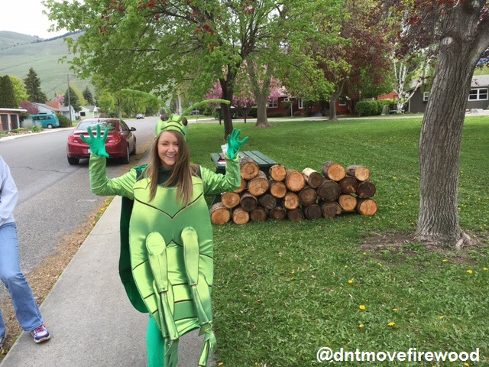

SCROLL THROUGH PAGES TO SEE ALL OPTIONS
Various Hungry Pests Social Media quality images below. Please visit the website for alternative ideas, images in higher resolution, and other items:
https://www.aphis.usda.gov/aphis/resources/pests-diseases/hungry-pests/usda-efforts/partner-tools
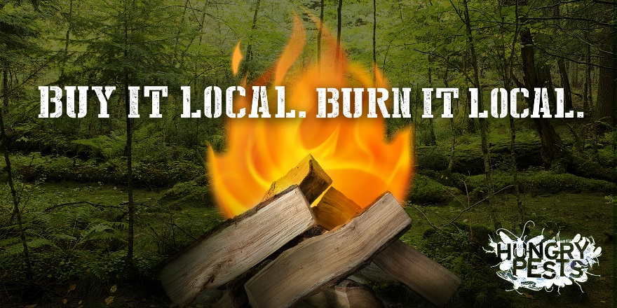
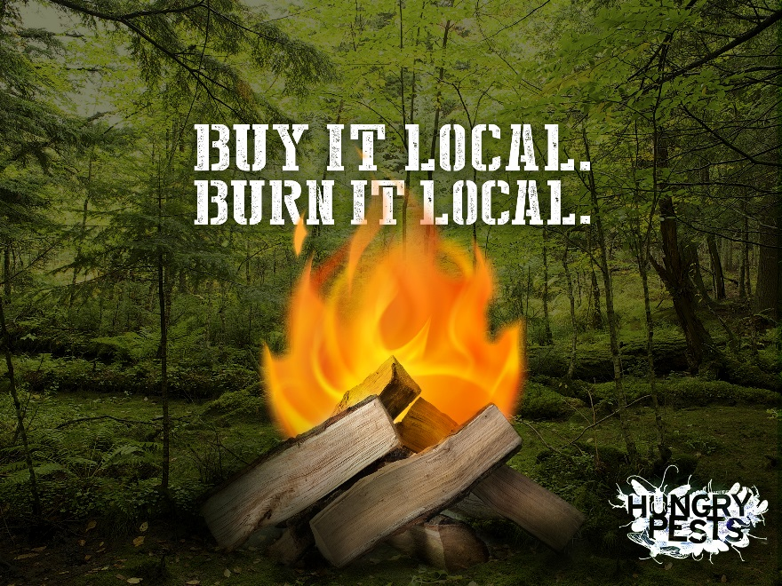

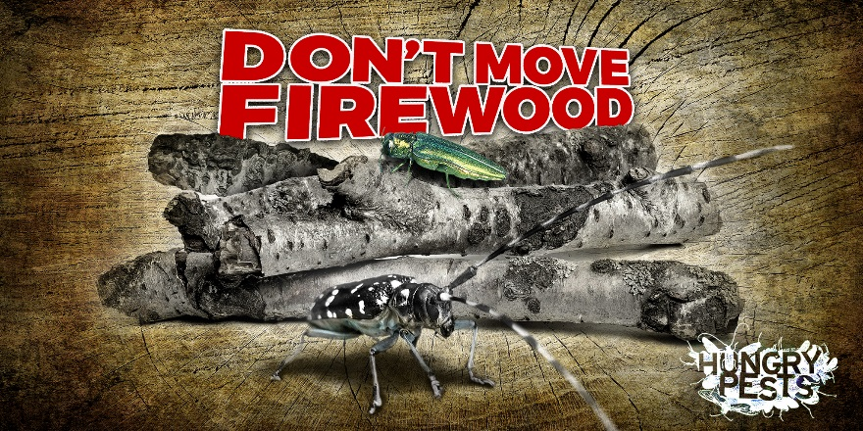
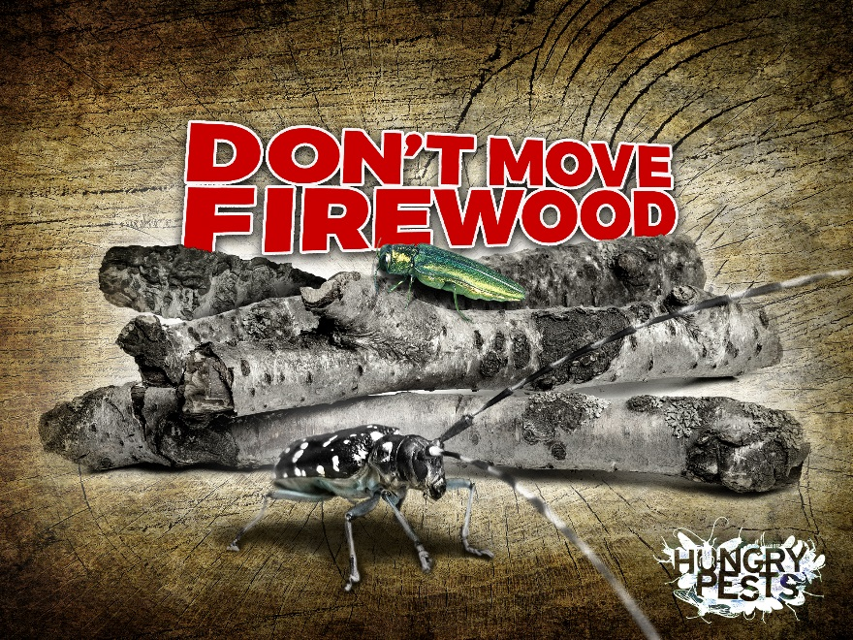
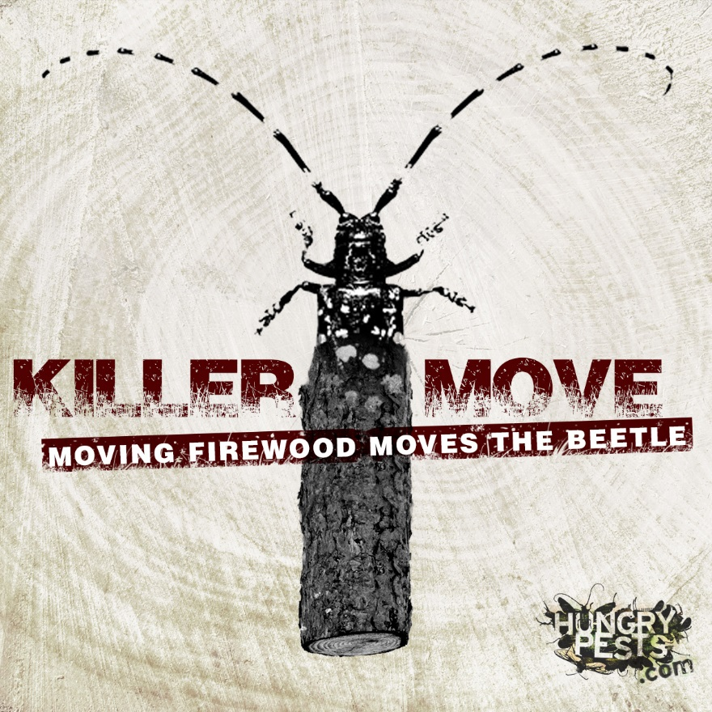
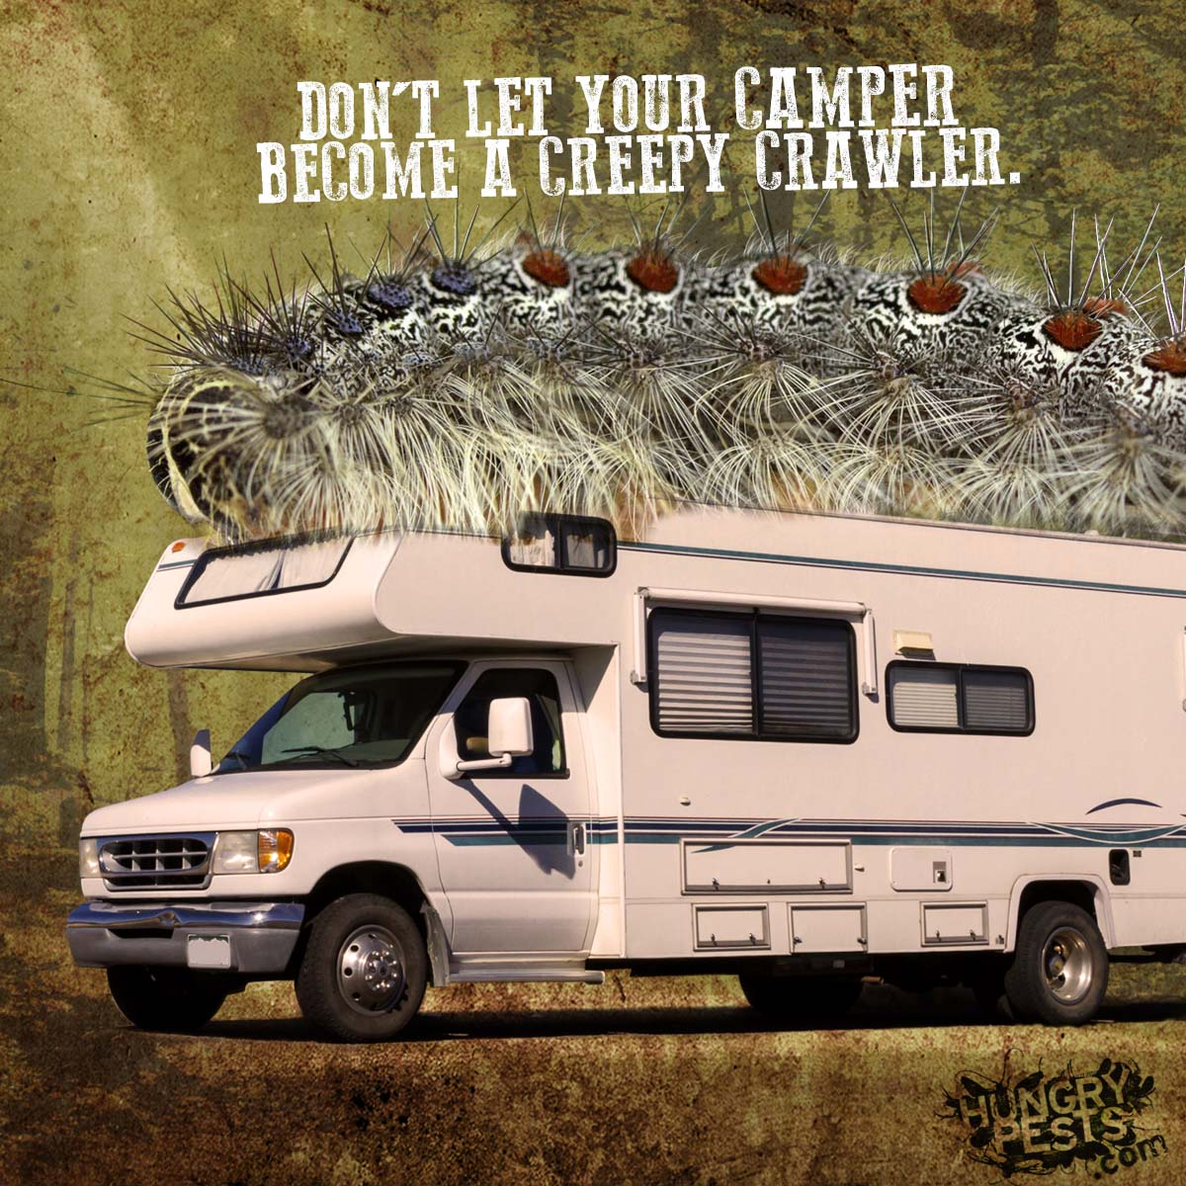
Various Don’t Move Firewood Social Media quality images below. Please visit the website much more:
https://www.dontmovefirewood.org/resource-library
